**YEAR ONE TECHNOVATOR PROGRAMME  
GROUP SUMMATIVE PROJECT**

**by**

**Class 1.13 Team 2**

**Mark Wong (21), Sean Lim (26), Taher Rangwala (27), Sriharsh Vutukuru (30)**

**PROPOSAL**

**Problem:**

Sleeping while driving is a major issue around the world – there are many reports of people who have crashed their vehicle while driving simply because they did not have much sleep last night. One example of this is when a bus captain fell asleep and crashed, injuring 3 passengers. (<https://mothership.sg/2022/08/bus-captain-sleep-crash-jailed-yishun/>) There are other cases of this happening. A drunk taxi driver fell asleep and swerved and collided with a car. (<https://www.channelnewsasia.com/singapore/drunk-taxi-driver-fall-asleep-wheel-hit-run-sle-2585511>) Clearly, this issue is extremely dangerous and can cause fatalities. Statistics have also shown that many people have experienced sleeping while driving before.

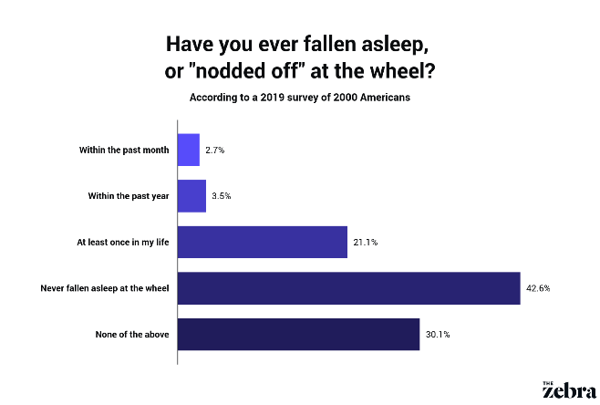

Figure 1 https://www.thezebra.com/resources/research/drowsy-driving-statistics/

**Solution:**

Our solution to this problem is a sleep detector. There will be a MicroBit attached to a strap placed on the side of the head (above ear) of the driver. The MicroBit will keep track of the angle of which it is tilted. If the driver falls asleep, or starts dozing off, the MicroBit’s tilt will most likely go beyond the range and will start beeping into the person’s ear, causing them to wake up to control the car again, or swerve away from the thing they are about to crash in, reducing the likelihood of injuries and fatalities.

**What we hope to achieve:**

We hope to achieve a decrease in the number of car accidents due to sleeping or drowsiness, as well as the number of injuries and fatalities that come with the car accidents.

**Similar ideas**

* <https://thegadgetflow.com/portfolio/anti-sleep-alarm/>
  + The design is $189. Very expensive.
* <https://www.kickstarter.com/projects/creativemode/steer-you-will-never-fall-asleep-while-driving/description>
  + According to comments, the person who started the project has most likely given up on the project.

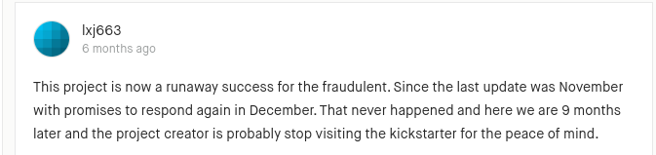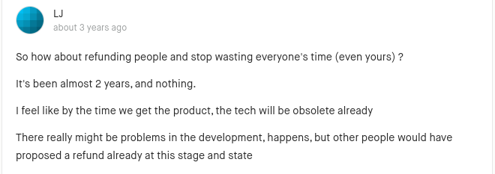

* <https://apps.apple.com/us/app/awake-drowsy-driving/id1493097609>
  + Partly relies on eye detection which might give people with naturally small eyes
  + Needs an iPhone
  + By constantly checking if eyes are closed, as well as monitoring heart rate, it will drain out the battery quickly and is not suitable for long trips or phones with a low battery capacity
* <https://techcrunch.com/2019/01/06/ellcies-glasses-know-if-youre-falling-asleep-while-driving/>
  + No reliable information on this
  + All other sources copy each other with slight paraphrasing
  + Allegedly costs $250